# **Hunter Richards CS 340 README – Project Two**

## About the Project This project revolves around an application designed to provide users with access to the "Austin Animal Center (AAC)" database through a Jupyter Dashboard. The dashboard is built using the Read function from the " MongoAACCrud.py" file and incorporates code from the "Hunter Richards Project Two Readme.ipynb" file. Upon execution, the application launches a Jupyter Dash page on the specified port address and offers interactive features such as a data table, pie chart, and geolocation map. All the data presented in these widgets is sourced directly from the AAC CSV file and can be easily filtered by users using various options.

## Motivation

## The genesis of this project was a request from our client, Grazioso Salvare, who sought a solution to enhance data interaction and visualization within the AAC database. Our objective was to create a functional Mongo DB dashboard, as outlined in the "Project Two Guidelines and Rubric" (n.d.). This dashboard empowers users to explore data through radial button filters, pie chart representations, and an ever-updating geolocation map. These diverse tools offer users multiple perspectives for examining the statistical disparities among the various data categories stored in the database.

## Getting Started

1. Create a Python CRUD class to handle the "Read" functionality, allowing you to fetch all documents within a specified MongoDB collection.
2. Begin the Project Two IPYNB by authenticating the user account using the correct username and password associated with the AAC collection.
3. Set up the Mongo Dashboard with a distinctive identifier (Name) and incorporate the Grazioso Salvare logo into the header.
4. Construct database queries that retrieve data from the collection and organize it into a structured data table, categorizing each piece of information.
5. Implement interactive features for the data table, such as the ability to select rows and utilize radial buttons to filter data based on various criteria (e.g., Water Rescue, Mountain or Wilderness Rescue, Disaster or Individual Tracking, or Reset).
6. Design a dynamic geolocation map that updates in real-time based on the actively selected row in the data table.
7. Create a dynamic pie chart that adjusts dynamically based on the criteria chosen through the radial buttons.

**Challenges:** During the development process, I encountered challenges related to handling empty or malformed data. To mitigate this, I incorporated validation checks and robust exception handling within each CRUD operation. This ensures that the module gracefully handles anomalies and provides meaningful feedback to the user. I recommend you also confirm the data is being read correctly, which was an issue I ran into. This can be tested through various console callout functions to ensure the data appears correct and proper.

## Installation

## Essential Software Requirements:

* **Python:** The primary programming language for the module. Chosen for its readability, flexibility, and extensive library support. [[Install Guide]](https://wiki.python.org/moin/BeginnersGuide/Download)
* **MongoDB:** A popular NoSQL database used to store the AAC dataset. It was chosen due to its scalability and performance in handling large datasets. [[Install Guide]](https://www.mongodb.com/docs/manual/installation/)
* **PyMongo:** The official MongoDB driver for Python. This library facilitates the connection and interaction between Python and MongoDB. It was chosen for its reliability, ease of use, and extensive documentation. [[Install Guide]](https://pypi.org/project/pymongo/)
* **Jupyter Notebook**: An open-source web application that allows users to create and share documents containing live code, equations, visualizations, and narrative text. Chosen for its interactive computing environment, extensive support for various programming languages (especially Python), and its widespread use in the data science community. [[Install Guide]](https://jupyter.org/install)
* **Jupyter Dash:** An extension for Jupyter Notebook that enables the creation of interactive web-based dashboards, simplifying data visualization and sharing within your Jupyter environment. [[Install Guide]](https://pypi.org/project/jupyter-dash/)

### Code Example

1. **Integrate Animal Shelter Module:** To access the CRUD class, simply integrate the Animal Shelter module using the "from MongoAACCrud import AnimalShelter" import function.
2. **Establish MongoDB Credentials:** Ensure access to the AAC user account's designated collection by configuring the MongoDB username and password.
3. **Retrieve All Records:** Utilize the "Read" CRUD function to retrieve all documents from the collection seamlessly.
4. **Apply Radial Filters:** Enable the selection of specific criteria for navigating the data table by implementing a "filter-type" option with radio items.
5. **Interactive Data Table:** Activate the data table with dynamic features, such as sortable rows and selectable options, using "dash_table.DataTable."
6. **Generate Pie Chart:** Visualize data from the data table by creating a pie chart through the use of "dcc.graph" and "px.pie."
7. **Display Geolocation Map:** Present geographical data related to the selected row from the data table by initializing a map using "dl.map" and providing coordinate positions.

### Tests

You can assess the code's integrity by incorporating the CRUD Python module into the Project Two Jupyter Notebook file. Subsequently, you can initialize the dashboard. Utilizing the "Read" function from the CRUD module, you can retrieve and transfer AAC database records to the dashboard. This information will then be structured within a data table, with each document being divided into distinct columns. Upon selecting a radial filter, the data table will exclusively display specific criteria. Alternatively, choosing a column will cause the geolocation map to display only the location corresponding to that column's input.

**Default Landing Page:**

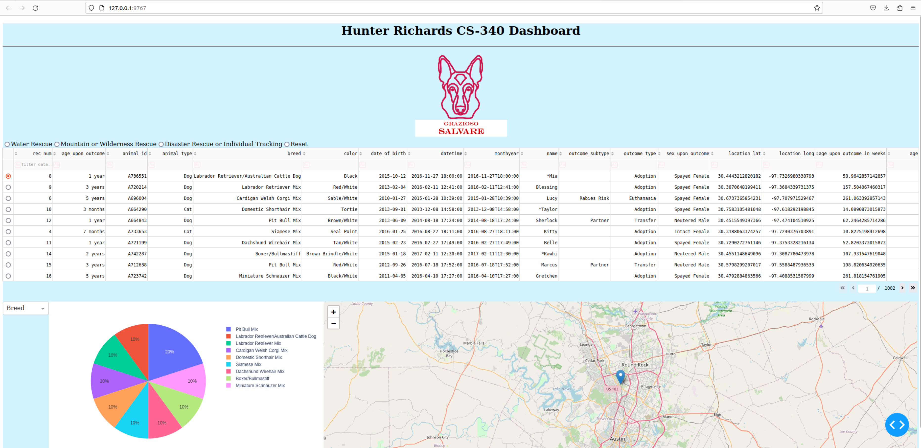

**Water Rescue Filter Option:**  
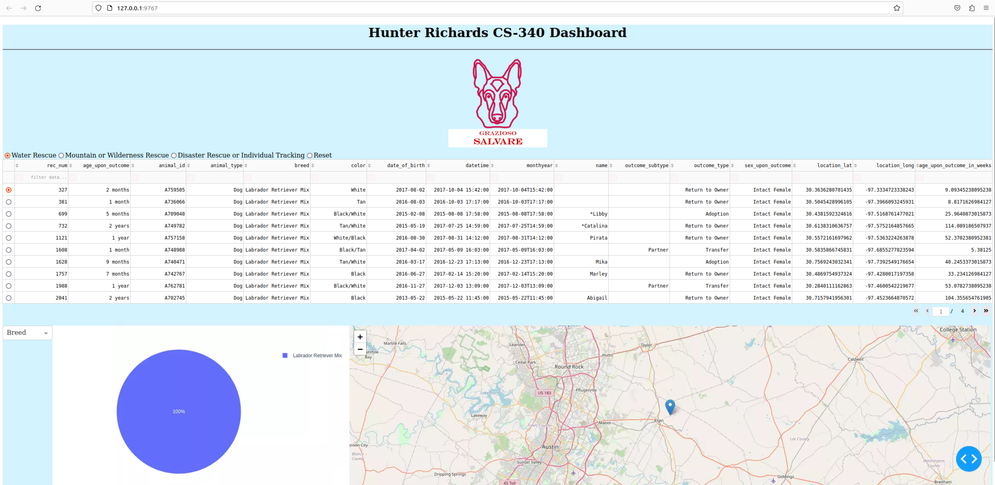**Mountain or Wilderness Rescue Filter Option:**

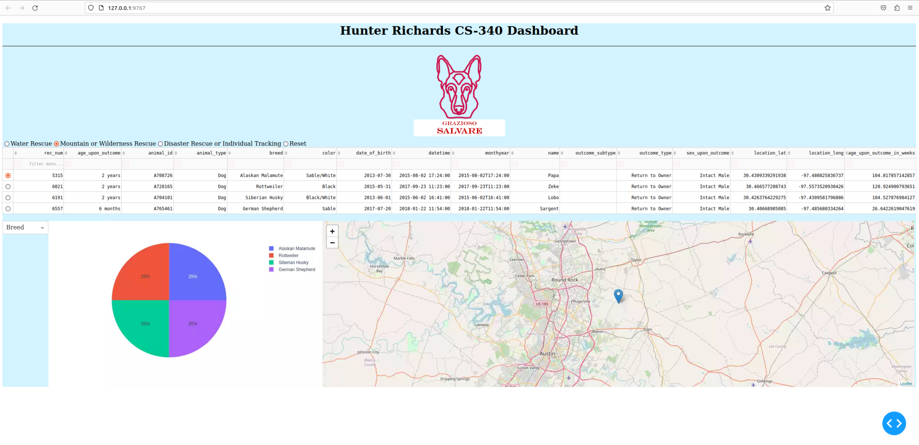

**Disaster Rescue or Individual Tracking Filter Option:**

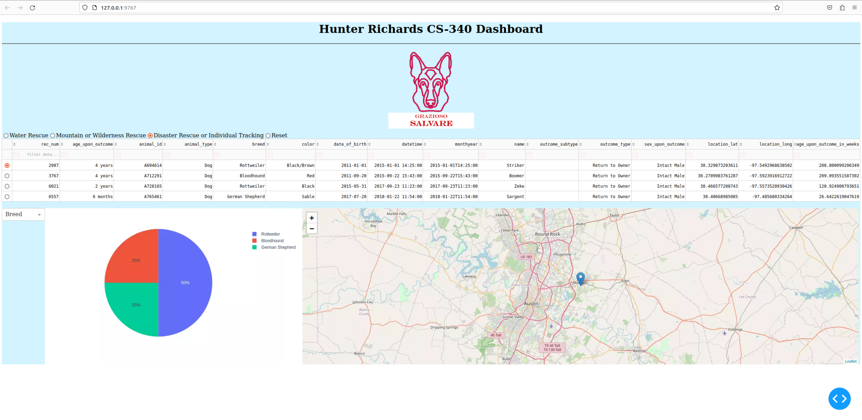

**Reset (defaults to all entries):**

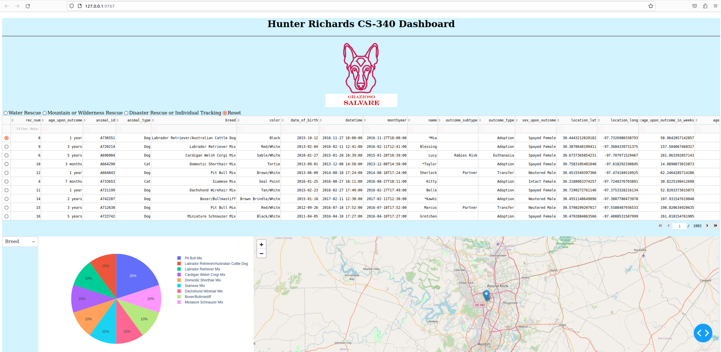

## Roadmap/Features

The upcoming enhancements for this program will give utmost importance to the incorporation of all CRUD operations. Users will have the capability to effortlessly create, view, modify, and delete database entries directly from the user-friendly Dashboard interface. This advancement will streamline database management, eliminating the need for manual code updates or reliance on terminal commands.

## Contact

Hunter Richards